Spearman rank correlation: EURUSD and USDCHF
Method 02 / daily log returns / Alpari D1 full available history

Study setup
Logical pair: EURUSD , USDCHF
Broker symbols: EURUSD_i , USDCHF_i
Snapshot: 2026-11-03_majors_alpari_D1
Timeframe: D1
Matched return window: 1999-01-05 to 2026-11-02 (UTC bar dates)
Matched return count n: 7186
Dropped unfinished last bar dated 2026-11-03 UTC after a tick-volume check against the prior complete day.
Complete matched rows (CSV): EURUSD-USDCHF_Spearman_D1.csv
Complete matched rows (HTML table): EURUSD-USDCHF_Spearman_D1_data.html

Method carried forward
Spearman rho is Pearson correlation on the ranks of matched daily log returns of close, ln(close_t / close_t-1), in the broker quote direction. Ties use average ranks. Quotes are not inverted. rho is symmetric under swap of the two symbols. rho = 0 means no consistent rank-order link in this sample; it does not mean no link of any kind. The score is not a cause, not a lead, and not a trading signal. Daily rows are not independent draws, so the two-sided p-value and approximate Fisher interval are reported and treated as secondary to rho. Same-sample Pearson r is shown only as a side check; a large rho minus r gap can flag outliers or a non-straight link.

Results
Spearman rho: -0.823916
Two-sided p-value: 0
Approximate 95% Fisher interval: [-0.831203, -0.816346]
Same-sample Pearson r: -0.749204
rho minus r: -0.074713

Conclusion
Over 7186 matched daily log-return rows for EURUSD and USDCHF (broker quote directions unchanged), Spearman rho is -0.8239 (negative, strong rank-order association in this sample). Approximate 95% Fisher interval: [-0.8312, -0.8163]. Same-sample Pearson r is -0.7492 (rho minus r = -0.0747). Two-sided p under the usual independent-ranks model is 0; that model does not match linked daily FX returns, so treat p as secondary. This does not establish cause, lead-lag, or a lasting trading rule.

Charts
Daily closes

Daily log returns
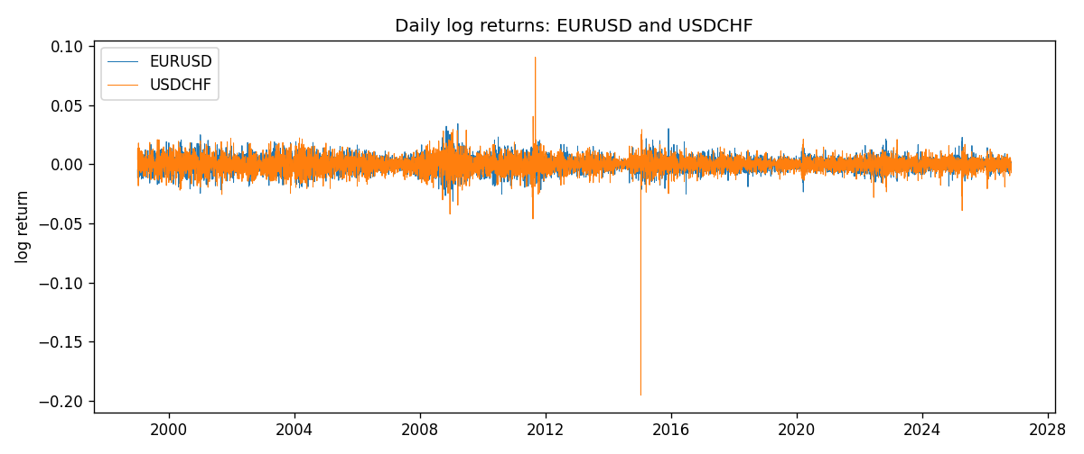
Log-return scatter
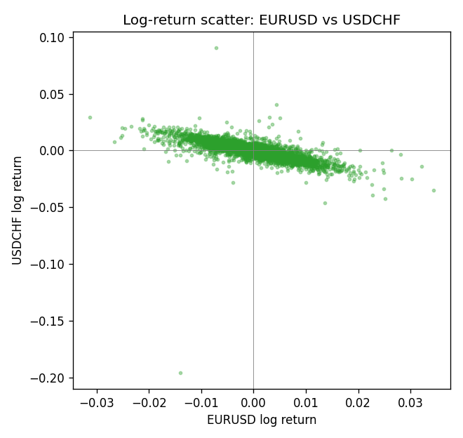
Rank-rank scatter
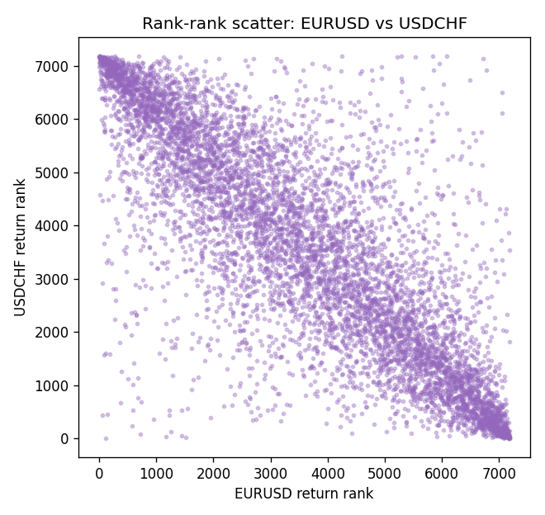

Data report
Every matched row that entered Spearman rho is stored in the sibling CSV named EURUSD-USDCHF_Spearman_D1.csv. That file is the complete data archive for redrawing charts. Embedding all rows as a Word table is impractical at this length; the Word file holds the column list, column summaries, and the first and last 15 matched rows.
Columns: time, EURUSD_open, USDCHF_open, EURUSD_high, USDCHF_high, EURUSD_low, USDCHF_low, EURUSD_close, USDCHF_close, EURUSD_tick_volume, USDCHF_tick_volume, EURUSD_spread, USDCHF_spread, EURUSD_real_volume, USDCHF_real_volume, EURUSD_log_return, USDCHF_log_return
Column summaries (matched calculation rows)
column | count | mean | std | min | 25% | 50% | 75% | max
EURUSD_open | 7186 | 1.181536 | 0.15083018 | 0.8272 | 1.086205 | 1.16621 | 1.29401 | 1.5995
USDCHF_open | 7186 | 1.0974503 | 0.25221737 | 0.72022 | 0.9205325 | 0.9899 | 1.23765 | 1.8219
EURUSD_high | 7186 | 1.1866696 | 0.15143104 | 0.8326 | 1.090285 | 1.17131 | 1.299445 | 1.6038
USDCHF_high | 7186 | 1.102742 | 0.25396197 | 0.73305 | 0.924775 | 0.99353 | 1.2422 | 1.8313
EURUSD_low | 7186 | 1.1765242 | 0.15015364 | 0.8227 | 1.0820725 | 1.16258 | 1.2885325 | 1.5865
USDCHF_low | 7186 | 1.0923313 | 0.25063382 | 0.08565 | 0.91721 | 0.98623 | 1.2315 | 1.8121
EURUSD_close | 7186 | 1.1815785 | 0.15080545 | 0.8267 | 1.0860875 | 1.166185 | 1.2941 | 1.5997
USDCHF_close | 7186 | 1.0974447 | 0.25212504 | 0.72025 | 0.920795 | 0.98995 | 1.237525 | 1.8217
EURUSD_tick_volume | 7186 | 103207.57 | 173534.06 | 218 | 9426 | 52774.5 | 99579.75 | 1471626
USDCHF_tick_volume | 7186 | 74325.102 | 113489.5 | 18 | 12800 | 40232.5 | 70435.25 | 858589
EURUSD_spread | 7186 | 19.339549 | 16.550572 | 0 | 8 | 12 | 20 | 50
USDCHF_spread | 7186 | 26.036877 | 24.695014 | 0 | 5 | 16 | 50 | 100
EURUSD_real_volume | 7186 | 4.0330482e+10 | 1.6691688e+11 | 0 | 0 | 0 | 0 | 3.6149665e+12
USDCHF_real_volume | 7186 | 2.3290849e+10 | 8.9127816e+10 | 0 | 0 | 0 | 0 | 1.9331921e+12
EURUSD_log_return | 7186 | -3.06e-06 | 0.00580427 | -0.03123819 | -0.00324267 | 0 | 0.00325778 | 0.03433183
USDCHF_log_return | 7186 | -6.921e-05 | 0.00659379 | -0.19545699 | -0.00335085 | 8.077e-05 | 0.003323 | 0.09051364
First 15 matched rows (selected columns)
time | EURUSD_close | USDCHF_close | EURUSD_log_return | USDCHF_log_return | EURUSD_tick_volume | USDCHF_tick_volume
1999-01-05 | 1.1758 | 1.3724 | -0.0048360507 | 0.0039424743 | 4793 | 4666
1999-01-06 | 1.1623 | 1.3912 | -0.011547966 | 0.013605652 | 4828 | 3740
1999-01-07 | 1.1712 | 1.3782 | 0.0076280636 | -0.0093883841 | 5076 | 4262
1999-01-08 | 1.1585 | 1.3935 | -0.010902799 | 0.011040268 | 5120 | 5991
1999-01-11 | 1.1503 | 1.4009 | -0.007103287 | 0.0052963193 | 4960 | 5236
1999-01-12 | 1.1555 | 1.3872 | 0.0045103728 | -0.0098275602 | 5248 | 5975
1999-01-13 | 1.1681 | 1.3621 | 0.010845346 | -0.018259701 | 6623 | 7036
1999-01-14 | 1.1681 | 1.3588 | 0 | -0.0024256692 | 5472 | 5825
1999-01-15 | 1.1563 | 1.3834 | -0.010153245 | 0.01794228 | 6529 | 7434
1999-01-18 | 1.1605 | 1.379 | 0.0036256946 | -0.0031856384 | 4054 | 4965
1999-01-19 | 1.1603 | 1.3789 | -0.00017235436 | -7.2518946e-05 | 5595 | 5494
1999-01-20 | 1.1566 | 1.3889 | -0.0031939256 | 0.0072259871 | 5736 | 5477
1999-01-21 | 1.1601 | 1.3836 | 0.0030215416 | -0.0038232689 | 5230 | 4736
1999-01-22 | 1.1587 | 1.3834 | -0.0012075213 | -0.0001445609 | 4559 | 4833
1999-01-25 | 1.1552 | 1.3868 | -0.0030251979 | 0.0024546976 | 3774 | 3996
Last 15 matched rows (selected columns)
time | EURUSD_close | USDCHF_close | EURUSD_log_return | USDCHF_log_return | EURUSD_tick_volume | USDCHF_tick_volume
2026-10-13 | 1.11965 | 0.83244 | 0.0037402957 | -0.0024955621 | 54238 | 32763
2026-10-14 | 1.11545 | 0.83489 | -0.0037582255 | 0.0029388325 | 62973 | 40903
2026-10-15 | 1.12172 | 0.82676 | 0.0056053107 | -0.0097855323 | 77110 | 54132
2026-10-16 | 1.12371 | 0.82377 | 0.0017724895 | -0.0036230826 | 61341 | 47176
2026-10-19 | 1.12086 | 0.82677 | -0.0025394633 | 0.0036351779 | 58324 | 40610
2026-10-20 | 1.12354 | 0.8246 | 0.0023881672 | -0.0026281224 | 52645 | 42106
2026-10-21 | 1.12318 | 0.82427 | -0.00032046717 | -0.00040027413 | 49937 | 37648
2026-10-22 | 1.12139 | 0.82032 | -0.0015949606 | -0.0048036381 | 60304 | 50809
2026-10-23 | 1.11989 | 0.82497 | -0.001338521 | 0.005652514 | 56197 | 45872
2026-10-26 | 1.11735 | 0.82649 | -0.0022706559 | 0.0018407959 | 52040 | 41336
2026-10-27 | 1.11272 | 0.82865 | -0.004152342 | 0.0026100526 | 56245 | 35560
2026-10-28 | 1.1152 | 0.82781 | 0.0022262927 | -0.0010142111 | 61037 | 42431
2026-10-29 | 1.11772 | 0.82379 | 0.0022571351 | -0.0048680164 | 73892 | 53780
2026-10-30 | 1.11644 | 0.82438 | -0.0011458446 | 0.00071594559 | 70119 | 55459
2026-11-02 | 1.11881 | 0.81851 | 0.002120569 | -0.0071459744 | 59416 | 45329

